Use this command to save the fig in matplotfig. Comment plt.show()

#plt.show()

plt.savefig('Feature_Importances.png', format='png', dpi=300)

Plot 1

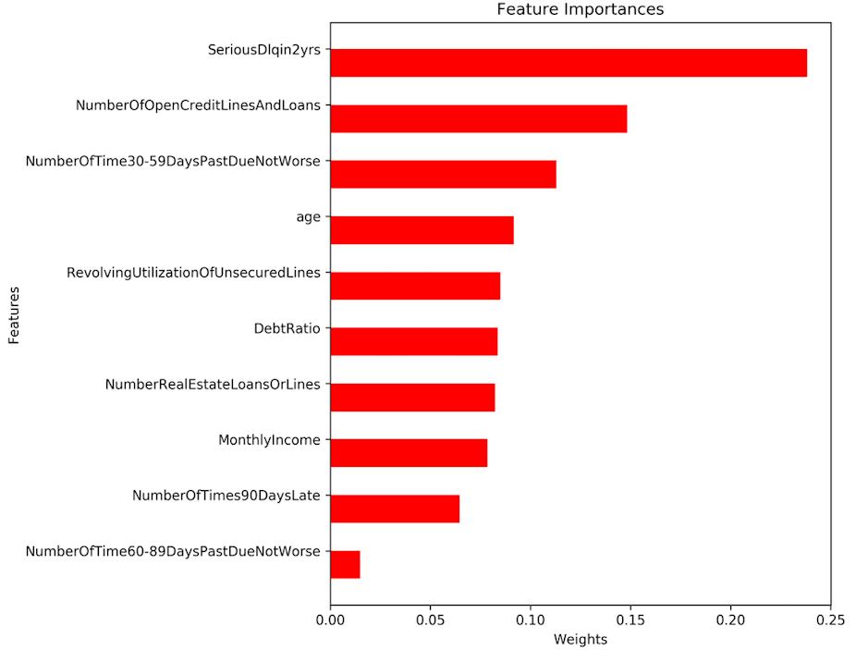

Please explain this plot using at least 100 words. And answer these questions:

1. What is the purpose and content of this model?

2. Is this plot meaningful? Why?

3. What can you learn from this plot?

4. Can you explain this plot based on the context of the data?